ECommerceHibernate
This is a flow diagram.
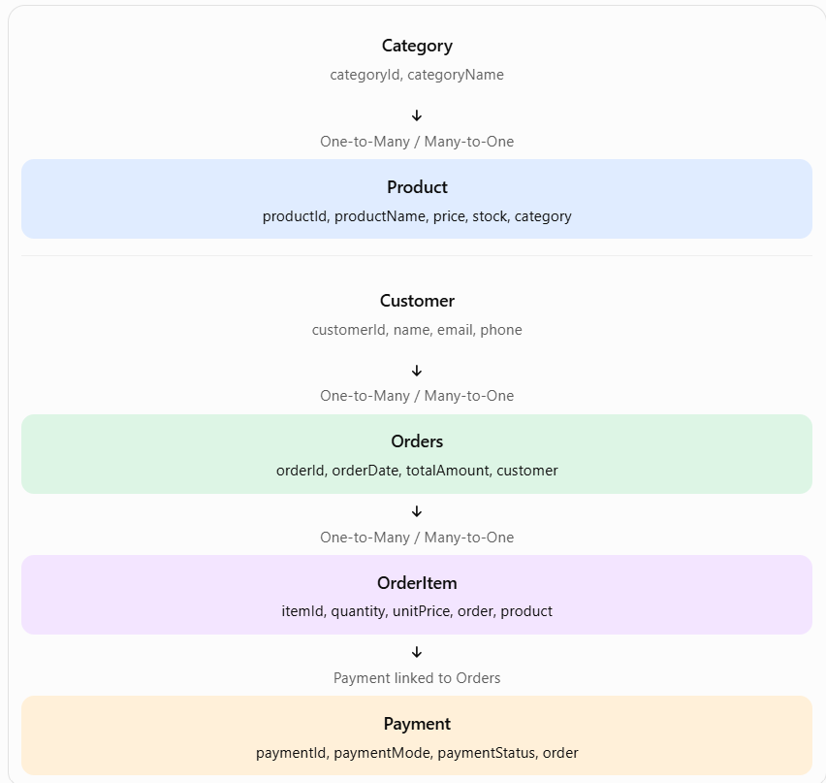
What should each Java class contain?
Start with these attributes. Use ordinary Java classes with private fields, a no-argument constructor, getters, and setters.
Class | Fields
Category | int categoryId, String categoryName
Product | int productId, String productName, double price, int stock, Category category
Customer | int customerId, String name, String email, String phone
Orders | int orderId, Date orderDate, double totalAmount, Customer customer
OrderItem | int itemId, int quantity, double unitPrice, Orders order, Product product
Payment | int paymentId, String paymentMode, String paymentStatus, Orders order

Understand the purpose of each package
Package / file | Responsibility
entity | Java classes representing database entities
dao | Database operations: insert, fetch, update, delete
util | Creates and manages Hibernate's SessionFactory
main | Runs the application and demonstrates functionality
resources | Hibernate configuration and XML mapping files
test | Tests individual mappings and database operations

- pom.xml - Maven dependencies
- src/main/java
  - com.ecommerce.entity
    - Category.java
    - Product.java
    - Customer.java
    - Orders.java
    - OrderItem.java
    - Payment.java
  - com.ecommerce.dao
    - CategoryDAO.java
      - getAllCategories()
      - addNewCategory()
    - ProductDAO.java
      - addNewProduct()
      - viewAllProducts()
      - viewProductById()
      - updateProduct()
    - CustomerDAO.java
    - OrderDAO.java
    - OrderItemDAO.java
    - PaymentDAO.java
  - com.ecommerce.util
    - HibernateUtil.java
    - Category_ProductOperations
      - addNewProduct()
      - viewAllProducts()
      - viewProductById()
      - updateProduct()
      - getAllCategories()
      - addNewCategory()
      - menu()
  - com.ecommerce.main
    - MainApp.java
Important design decisions:
- Use Orders as the Java class name to avoid confusion with SQL's ORDER keyword.
- For a production application, use BigDecimal rather than double for prices and monetary totals.
- Use java.time.LocalDateTime for order dates if supported by your Hibernate version and configuration.
- For this initial version, each entity can use a generated primary key with the identity generator, assuming MySQL auto-increment columns.
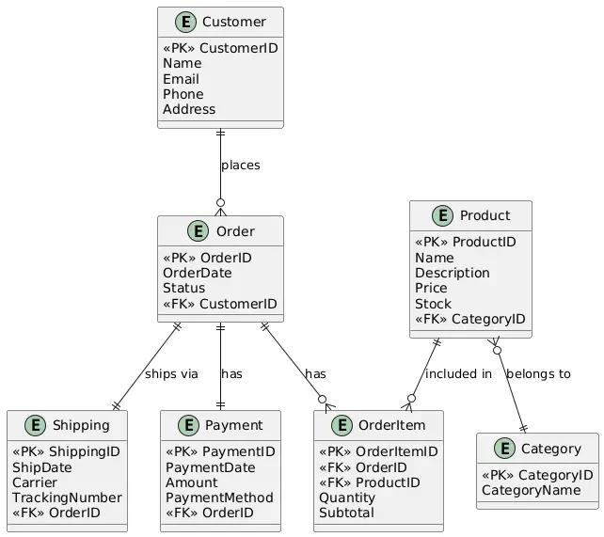
1. Entities and their relationships
Customer → Order
One-to-Many / Many-to-One
One customer can place many orders. Each order belongs to one customer.
Category → Product
One-to-Many / Many-to-One
One category can contain many products. Each product belongs to one category.
Order → OrderItem
One-to-Many / Many-to-One
One order contains multiple order items. Each order item belongs to one order.
Product → OrderItem
One-to-Many / Many-to-One
A product can appear in many order items over time. Each order item references one product.
Order → Payment
One-to-One
For a simple version, each order has one payment record. If you want retries, refunds, or installments, use a one-to-many relationship instead.
2. Database tables
Table | Columns
Customer | customerId (PK), name, email, phone
Category | categoryId (PK), categoryName
Product | productId (PK), productName, price, stock, categoryId (FK)
Orders | orderId (PK), orderDate, totalAmount, customerId (FK)
OrderItem | itemId (PK), quantity, unitPrice, orderId (FK), productId (FK)
Payment | paymentId (PK), paymentMode, paymentStatus, orderId (FK, unique for one-to-one)
Important: OrderItem is a separate entity, not just a many-to-many join table. It stores quantity and unitPrice, which are details specific to a product in a particular order.

